## **Install Arduino IDE in MacOS**

1. **Download the Arduino IDE MacOS version**

Download link：<https://www.arduino.cc/en/software/>

Arduino IDE 2.0 is not easy to use, so we use version 1.8.19.

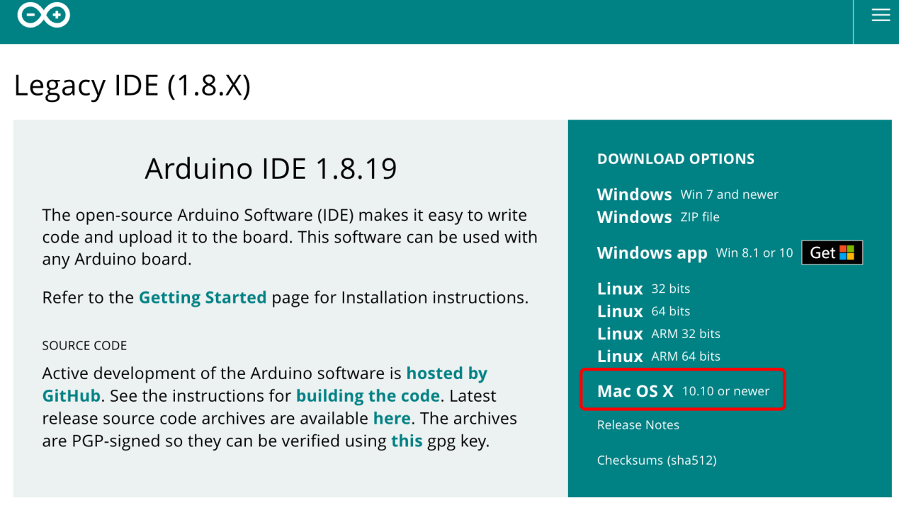

1. **Decompress the installation package**

After double click to decompress, it is installed successfully.

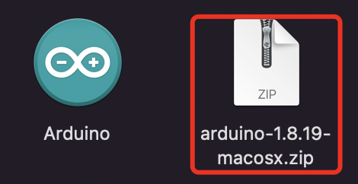

1. **Drag the Arduino IDE to application program**

For easy to use, we drag the Arduino IDE to application program.

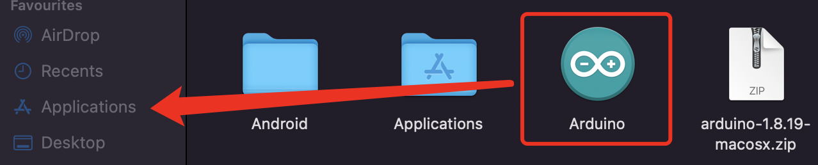

Then the Arduino IDE can be opened in the menu.

